*Article*

Identification of Alzheimer’s disease subtypes based on the enrichment of neural pathways

Nayila Abulimiti1, 2,3,4, Rongzhuo Long1, 2,3,4, Xiaosheng Wang1, 2,3,4, *

1 Biomedical Informatics Research Lab, School of Basic Medicine and Clinical Pharmacy, China Pharmaceutical University, Nanjing 211198, China

2 Intelligent Pharmacy Interdisciplinary Research CenterCancer Genomics Research Center, School of Basic Medicine and Clinical Pharmacy, China Pharmaceutical University, Nanjing 211198, China

3 Big Data Research Institute, China Pharmaceutical University, Nanjing 211198, China

4 Institute of Innovative Drug Discovery and Development, China Pharmaceutical University, Nanjing 211198, China

* Correspondence to: Xiaosheng Wang, E-mail: [xiaosheng.wang@cpu.edu.cn](mailto:xiaosheng.wang@cpu.edu.cn)

Abstract: Alzheimer’s disease (AD) is a neurodegenerative and highly heterogeneous disease. Thus, the identification of molecular subtypes of AD is important for the understanding of its heterogeneity and development of precision management of this disease. Here we proposed a neural pathways’ enrichment-based AD subtyping method. Based on the enrichment scores of 25 neural pathways, using hierarchical clustering, we identified three AD subtypes: Neu-H, Neu-M, and Neu-L, which displayed high, medium, and low neural pathways activity, respectively. We demonstrated that this subtyping method was reproducible through analysis six AD bulk datasets and a single-cell dataset. The Neu-L subtype was associated with more progressive AD outcomes, as evidenced by its high prevalence in late stages of AD and severe AD. Our analysis revealed that Neu-L had lower activity of DNA repair pathways than Neu-H, indicating a greater accumulation of genomic damage in the AD subtype with low activity of neural pathways. Moreover, Neu-H and Neu-L displayed the lowest and highest immune infiltration levels, respectively, indicating that immune or inflammation responses have an association with AD progression. Single-cell data analysis confirmed the presence of the three AD subtypes at the cellular level, and revealed that Neu-H was enriched in excitatory neurons, while Neu-L was enriched in inhibitory neurons. Our novel classification method offers insights into the molecular mechanisms underlying AD and highlights the potential for subtype-specific therapeutic strategies.

**Keywords:**Alzheimer’s disease; subtyping; neural pathway; clustering analysis; transcriptome

1. Introduction

Alzheimer’s disease (AD) is a critical public health issue, with over 10 million new cases of AD each year worldwide [1] AD is marked by its progressive neurodegenerative nature and significant impact on cognitive functions, memory, and behavior.[2] Although the presence of amyloid β plaques and neurofibrillary tangles is frequently observed in post-mortem analyses of AD patients,[3] the pathogenesis of AD remains incompletely understood, and effective treatments are still lacking. A number of studies have indicated that pathological changes in AD patients begin approximately 20 years prior to the onset of symptoms and diagnosis.[4] To date, only a few drugs, such as acetylcholinesterase inhibitors, have been approved by the FDA for AD treatment.[5]

AD is a highly heterogeneous disease, reflected in its varied clinical presentations and biological mechanisms.[6] Recent advances in transcriptomic and proteomic analyses have enabled the identification of distinct molecular subtypes of AD, enhancing our understanding of its pathophysiological diversity and precision medicine. Based on transcriptomic data, Neff et al. identified two major molecular subtypes of AD by using an integrative network approach.[7] Bredesen et al. identified three subtypes of AD based on their metabolic profiles.[8] Lai et al. identified two immune-specific subtypes of AD based on immune microenvironment-related gene expression patterns.[9]

Because AD is a neurodegenerative disorder, molecular classification of AD based on the activities of distinct neural pathways is meaningful, albeit such investigation remains lacking. To this end, here we uncovered AD subtypes by unsupervised clustering based on the enrichment of 25 neural pathways using transcriptomic data. We identified three AD subtypes showing significantly different activities of neural pathways. Moreover, we comprehensively compared molecular features among these subtypes.

2.Materials and Methods

**Datasets**

We downloaded six gene expression profiling datasets for AD, including ROSMAP,[10] GSE1297,[11] GSE5281,[12-15] GSE29378,[16, 17] GSE48350[18-23] and GSE122063.[24] The results published here are in whole or in part based on data obtained from the AD Knowledge Portal (https://adknowledgeportal.org). The ROSMAP dataset were obtained from The Religious Orders Study and Memory and Aging Project (ROSMAP) (https://www.synapse.org/#!Synapse:syn3219045). ROSMAP comprises two active longitudinal cohort studies that have recruited individuals aged 65 and over with unknown dementia in order to gather extensive clinical information prior to a comprehensive neuropathological examination at death. RNA-seq gene expression profiling data of the dorsolateral prefrontal cortex were available for 638 subjects.[25] We extracted 218 subjects whose clinical diagnosis of cognitive status was Alzheimer’s dementia in this study. The other datasets were downloaded from the NCBI gene expression omnibus (GEO) (https://www.ncbi.nlm.nih.gov/geo/).

We also downloaded a single-nucleus RNA sequencing (snRNA-seq) dataset (snRNAseqPFC_BA10) for AD from ROSMAP (https://www.synapse.org/#!Synapse:syn18485175).[26] This dataset included around 80,000 single nuclei derived from the dorsolateral prefrontal cortex of 48 postmortem human brain samples. These samples involved 24 age-matched individuals with a spectrum of mild-to-severe β-amyloid and other pathologies and 24 control individuals with no or very little pathology.

**Data preprocessing**

We imputed the missing values in gene expression matrix by the k-nearest neighbors (k-NN) algorithm implemented with the impute R package (version 1.72.3) with k = 10. We performed quantile normalization and log2 normalization of the gene expression values before subsequent analyses.

**Quantification of pathway activity or enrichment level**

We evaluated the pathway activity or enrichment level in a sample by the single-sample gene-set enrichment analysis (ssGSEA).[27] The algorithm outputs the enrichment score of a gene set in samples based on their gene expression profiles. We collected the gene sets representing neural Gene Ontology biological processes (GOBP) pathways from GSEA (http://www.gsea-msigdb.org/gsea/index.jsp).

**Clustering analysis**

We used hierarchical clustering to identify AD subtypes based on the enrichment scores of 25 neural pathways. This analysis was conducted using the R package “pheatmap” with the parameters: clustering_method = “ward.D2”, clustering_distance_cols = “euclidean”, and cutree_cols = 3. Principal component analysis (PCA) was used for effective dimensionality reduction, model identification, and grouping visualization of the data of the entire gene expression profiles.

**Dimensionality reduction and clustering of snRNA-seq data**

For the snRNA-seq dataset, all analyses were performed with Seurat (version 4.0).[28] Based on the expressions of known marker genes,[26] we annotated different cell types, and visualized the results by Uniform Manifold Approximation and Projection (UMAP).[29] In the single-cell dataset, we used the “AUCell” R package [30] to evaluate the enrichment score of a gene set in each cell.

**Differential expression analysis**

We used the “limma” R package to identify differentially expressed genes between different groups of samples with a threshold of p < 0.05 and mean expression fold change (FC) > 1.5.

**Evaluation of immune score**

We used ESTIMATE [31] to assess the immune score for each AD sample based on gene expression profiles. The immune score reflects the immune infiltration level in the tissue of AD patients.

**Pathway enrichment analysis**

Using GSEA,[32] we identified upregulated pathways in one class versus another class by inputting the upregulated DEGs in the class using a threshold of adjusted p-value < 0.05. In addition, we used WGCNA [33] to identify the gene modules and gene ontology terms differentially enriched in AD subtypes, with the input of gene expression profiles and sample classification.

**Statistical analysis**

We used the Mann–Whitney U test to compare two classes of non-normally distributed data and Student’s t test for normally distributed data. We employed Fisher’s exact test to assess the association between two categorical variables. All statistical analyses were performed in the R programming environment (version 3.6.1).

.

3. Results

1. **Neural pathways-based clustering analysis identifies three subtypes of AD**

Based on the enrichment scores of 25 neural pathways, we identified three AD subtypes by hierarchical clustering, consistent in six AD datasets (ROSMAP, GSE1297, GSE5281, GSE29378, GSE48350 and GSE122063). We termed the three subtypes Neu-H, Neu-M, and Neu-L, respectively, which displayed high, medium, and low enrichment levels of neural pathways (Fig. 1A). These consistent clustering results demonstrate the reproducibility of this AD subtyping method. Furthermore, we performed PCA of the six datasets based on the enrichment scores of the 25 neural pathways. This analysis confirmed the three subtypes to be clearly distinguished (Fig. 1B).



**Fig.1:** Identifying subtypes of Alzheimer's Disease based on Neural pathways.

a Hierarchical clustering of Alzheimer's Disease (AD) identifies three subtypes (Neu-H, Neu-M, and Neu-L) based on the enrichment levels of 25 Neural pathways in 6 different datasets (ROSMAP, GSE1297, GSE5281, GSE29378, GSE48350 and GSE122063). The enrichment levels of the pathways were evaluated by ssGSEA of all genes involved in them. b PCA confirms that ADs can be clearly separated into three subgroups based on the ssGSEA scores of the pathways. ImD immunity-deprived, Neu-H neuro high, Neu-M neuro medium, Neu-L neuro low (These also apply to the following figures).

1. **The AD subtypes have different clinical features**

We compared several clinical features among the three AD subtypes, including Braak stages, AD severity extent, and age. Braak staging is a proposed staging system based on the severity of neurogenic fiber tangles (NFTs), a primary biomarker of AD.[34] Braak stages I and II indicate that NFTs are mainly confined to the inner olfactory regions of the brain. Braak stages III and IV indicate the involvement of NFTs in limbic regions of the brain, such as the hippocampus. Braak stages V and VI indicate moderate to severe neocortical involvement.[35] Interestingly, we found that all Neu-L AD patients were at Braak stages of V and VI, compared to 60% of Neu-M and Neu-H patients being at Braak stages of V and VI (Fig. 2A). In another dataset, all Neu-L patients were diagnosed as severe AD, compared to 60% of Neu-M and 30% of Neu-H patients being severe (Fig. 2B). These data indicate that the AD patients with lower expressions of neural pathways are likely to have more severe clinical outcomes.

Age is the most significant risk factor for AD and the primary driver of disease progression. In general, the age of AD onset is relatively high in comparison to other diseases, and evidence have demonstrated that the AD incidence increases exponentially after 60 years old.[36] Of note, all of the AD patients in Neu-L were over the age of 90 (Fig. 2C).



**Fig.2**: Comparisons of clinical features among the AD subtypes

a-c Stacked bar chart of the proportion of the Braak stage(a), AD severity extent(b) and age(c) with the AD subtypes.

1. **The AD subtypes have different molecular features**

The accumulation of DNA damage is a well-established aging factor, and it has been shown that excitatory neurons in AD patients’ brains accumulate genomic damage to gradually result in functional impairs.[37] We compared the activities (enrichment scores) of six DNA repair pathways among the three AD subtypes. The six pathways included nucleotide excision repair (NER), base excision repair (BER), mismatch repair (MS), the Fanconi anemia (FA) pathway, homology-dependent recombination (HR), and non-homologous DNA end joining (NHEJ). We found that the enrichment scores of these pathways tended to be highest in Neu-H and lowest in Neu-L (Fig. 3A). It indicates a positive association between the enrichment of DNA repair pathways and neural pathways in AD patients. That is, the AD patients with lower activity of neural pathways have lower activity of DNA repair pathways. It is justified since the AD patients lowly expressing neural pathways have more inferior clinical outcomes and defects in DNA damage repair is an important pathological cause of AD.[38]

Numerous studies have suggested that the immune system may play a key role in AD.[39] We compared immune infiltration levels (or immune scores) among the three AD subtypes. Notably, the three AD subtypes showed significantly different immune scores: Neu-H < Neu-M < Neu-L, consistent in all six datasets (one-tailed Mann–Whitney U test, p < 0.05) (Fig. 3B). This result indicates a negative association between the activities of neural pathways and immune response. Indeed, Spearman correlation analysis showed that the enrichment scores of neural pathways had a significant negative correlation with immune scores (Fig. 3C). Since the AD patients with low activity of neural pathways have unfavorable clinical outcomes and strong immune signature, it suggests that immune responses or inflammation is associated with AD progression, aligning with previous reports. [40]



**3**: Comparisons of molecular features among the AD subtypes

a Comparison of enrichment scores of six DNA damage repair pathways between the PC subtypes. NER, nucleotide excision repair. BER, base excision repair. MS, mismatch repair. FA, Fanconi Anemia. HR, homologous recombination. NHEJ, non-homologous end-joining. b The immune scores are highest in Neu-L and lowest in Neu-H in all six datasets. c Spearman correlations between neural scores and imuune scores. The immune scores were evaluated by ESTIMATE[31].

1. **GO pathways** **enriched in the AD subtypes**

Based on gene expression profiles, we identified twenty gene modules by WGCNA [33] that significantly differentiated the AD subtypes (Fig. 4). The brown (p  = 0.002；r = 0.66), black (p  = 0.001；r = 0.68) and orange (p = 0.002；r = 0.67) modules were significantly upregulated in Neu-H. The representative GO terms associated with the three modules were “Glutamatergic synapse”, “Neurofilament” and “MHC protein complex”, respectively. It aligned with the highest enrichment of neural pathways in Neu-H. In contrast, the red (p = 0.008；r = 0.59) and lightyellow (p = 0.02；r = 0.51) modules were significantly upregulated in Neu-L. The representative GO terms associated with the two modules were “Humoral immune response mediated by circulating immunoglobulin” and “Epidermal growth factor receptor signaling pathway”, respectively. Again, it aligned with the highest immune signature observed in Neu-L. In addition, four gene modules were highly enriched in Neu-M, with representative GO terms of “Nuclear-transcribed mRNA catabolic process, nonsense-mediated decay”, “Astrocyte differentiation”, “Membrane organization”, and “Histone modification”.



**Fig.4**: Gene modules and their representative GO terms significantly differentiating AD by the subtypes in GSE1297 dataset. The correlation coefficients and P values (in parenthesis) generated by WGCNA[33] are shown.

1. **Validation of the subtyping method in single-cell data**

To explore the reproducibility of the AD subtyping method, we analyzed a snRNA-seq dataset (snRNAseqPFC_BA10) [26]. This dataset involved 35,494 AD single cells belonging to six cell types: excitatory neurons, inhibitory neurons, astrocytes, oligodendrocytes, oligodendrocyte precursor cells, and microglia (Fig. 5A). We used the AUCell algorithm [30] to calculate the enrichment scores of the 25 neural pathways in single cells, based on which we hierarchically clustered the AD single cells. Likewise, the 35,494 AD cells were classified into three subgroups, also termed Neu-H, Neu-M, and Neu-L, respectively (Fig. 5B). Interestingly, the Neu-H and Neu-M subtypes were primarily composed of excitatory neurons, while the Neu-L subtype was composed of the other diverse cell types. In addition, we found most inhibitory neurons belonging to Neu-L, indicating that the higher enrichment of inhibitory neurons in Neu-L versus other subgroups. In contrast, Neu-H had a higher enrichment of excitatory neurons than Neu-M and Neu-L (Fig. 5C). Moreover, as the AD progression, the proportion of Neu-H cells decreased gradually, while the proportion of Neu-L cells exhibited a gradual increase (Fig. 5D). These results supported the conclusions drawn from bulk data.

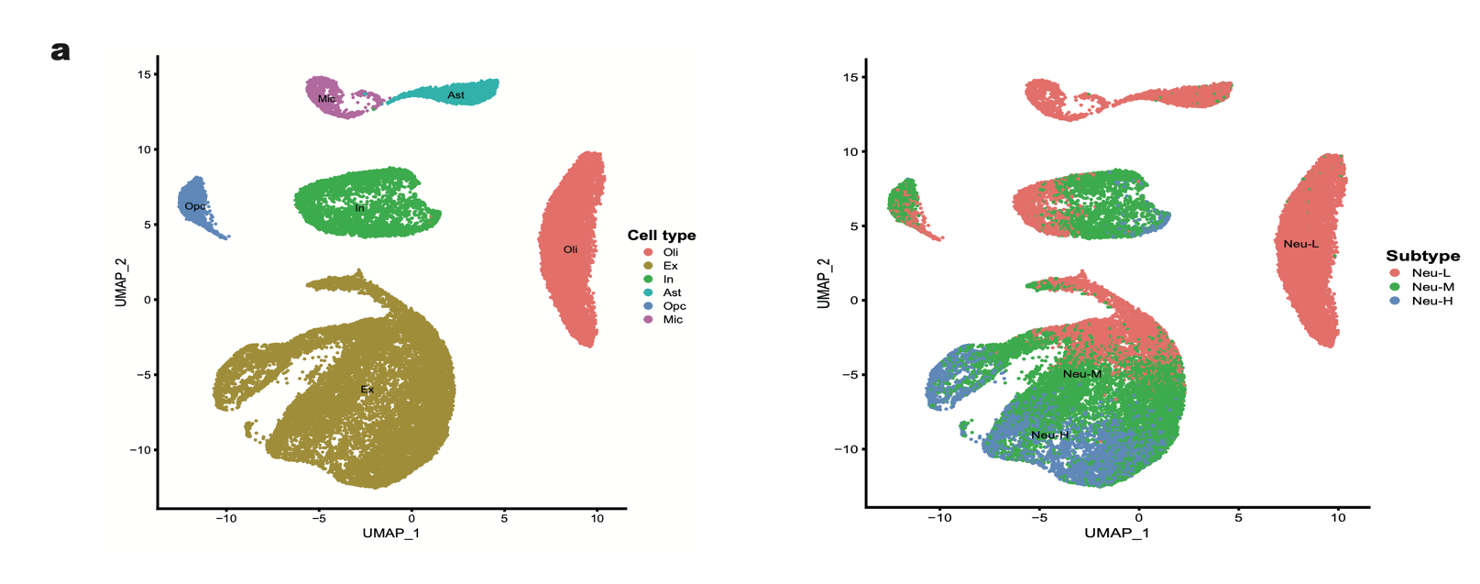

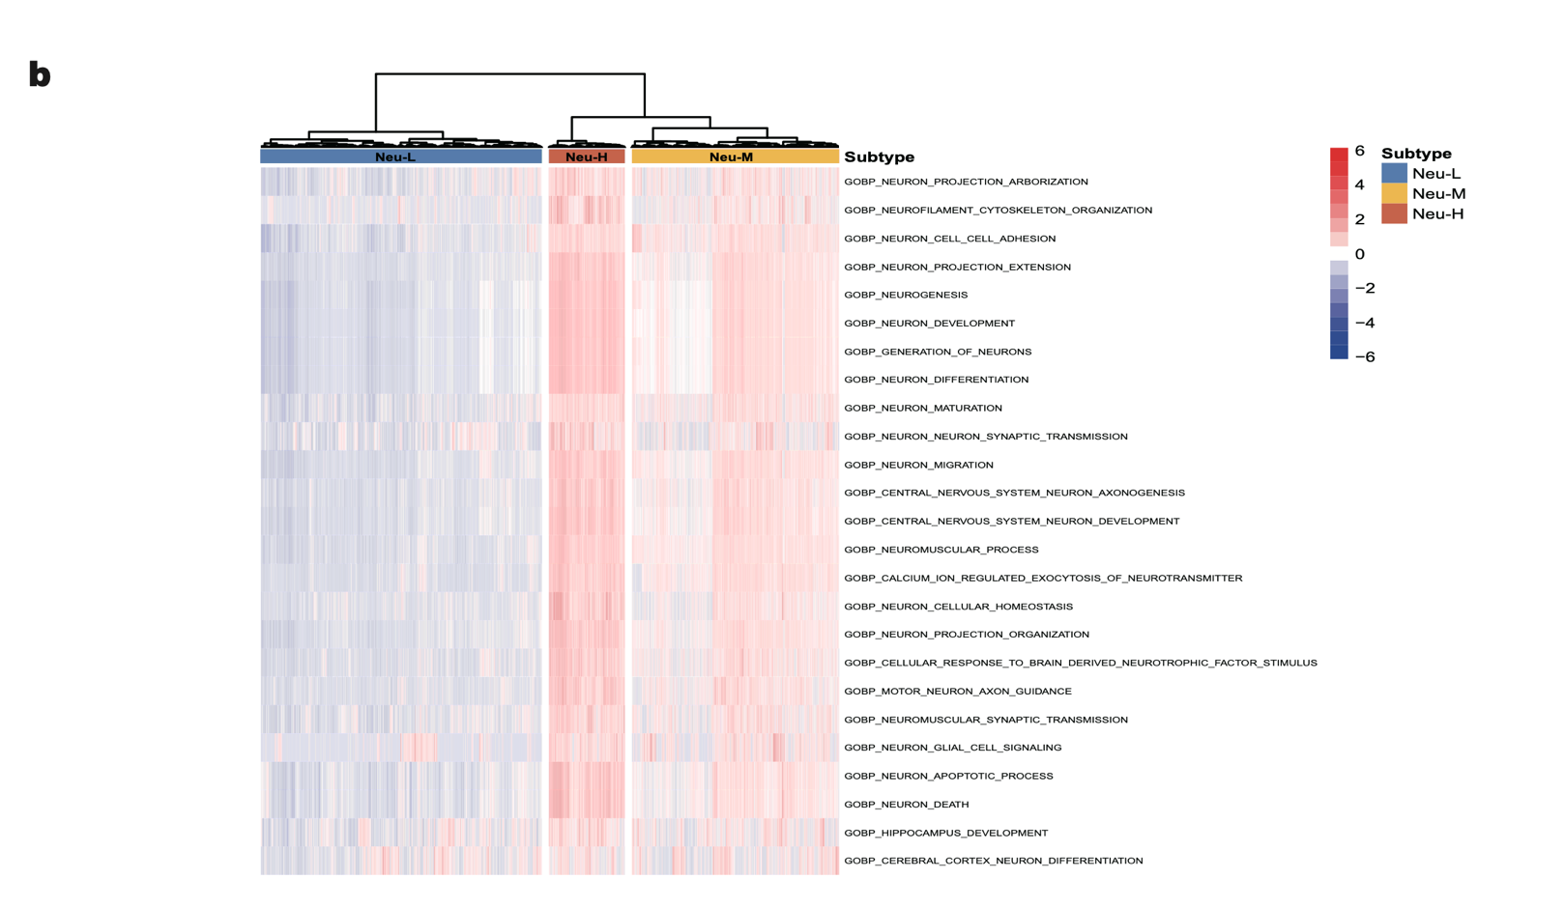

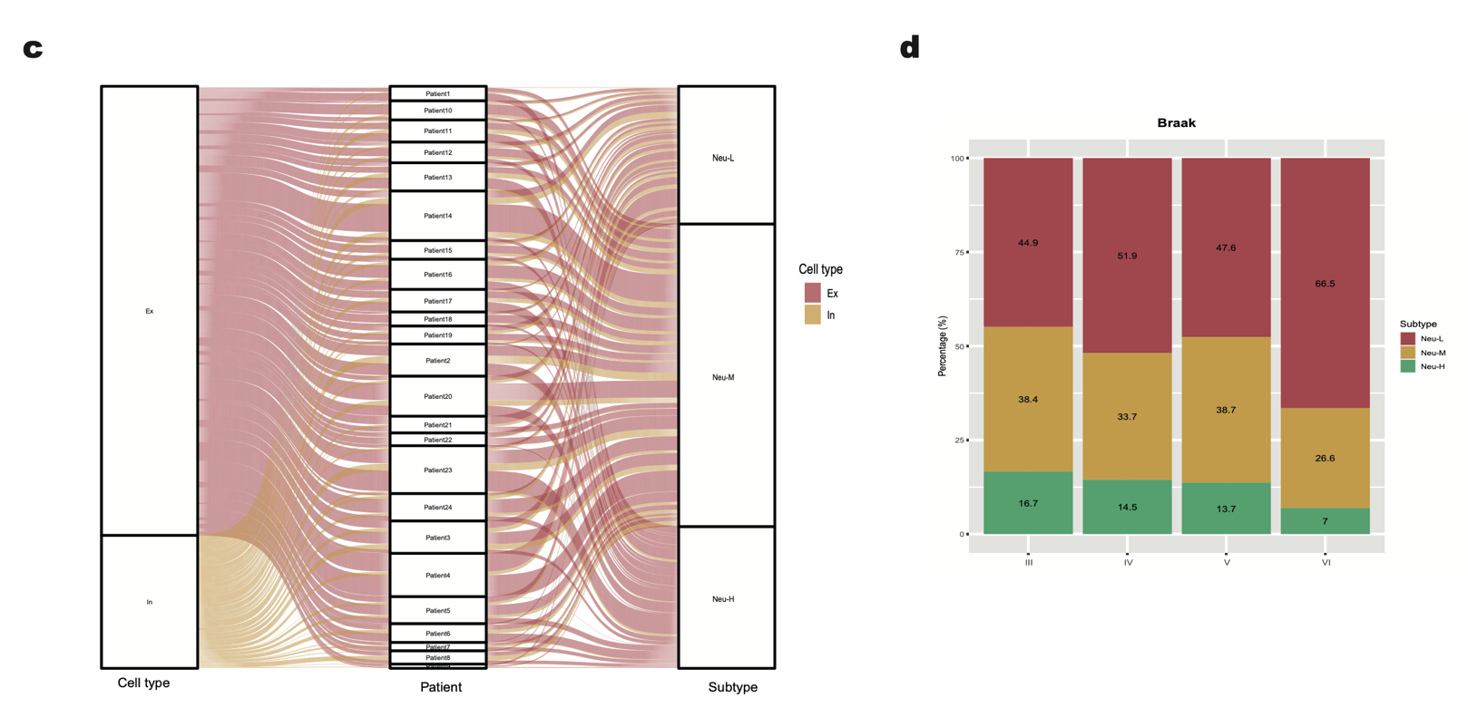

**Fig.5**: Validation of the subtyping method in a scRNA-seq dataset

a Clustering of 35,494 AD cells by the UMAP algorithm[29]. b Hierarchical clustering of 35,494 AD cells based on the enrichment scores by AUcell of 24 neuro-related pathways identifies three subgroups. c Proportions of AD cells classified into Neu-L, Neu-M and Neu-H and Ex and In cell types in each of 24 AD patients, respectively. d Stacked bar chart of the proportion of the Braak stage with the AD subtypes of 35,494 AD cells. Ex, excitatory neurons. In, neurons. Ast, astrocytes. Oli, oligodendrocytes. Opc, oligodendrocyte precursor cells. Mic, microglia.

4. Discussion

This For the first time, we proposed a neural pathways-based classification method for AD. Based on the enrichment scores of 25 neural pathways, we identified three AD subtypes, which displayed high, medium, and low activity of neural pathways, respectively. Furthermore, we have demonstrated that this subtyping method is reproducible by analyzing six AD bulk datasets and a single-cell dataset. Our findings indicate that the Neu-L subtype is associated with more progressive AD outcomes, as evidenced by the high prevalence of this subtype in late stages of AD and severe AD. Our analysis revealed that Neu-L had lower activity of DNA repair pathways than Neu-H, indicating a greater accumulation of genomic damage in the AD subtype with low activity of neural pathways. This supports the previous findings that genomic damage is an important contributor to AD pathology.[41] An interesting finding is that Neu-H and Neu-L have the lowest and highest immune infiltration levels, respectively. It indicates that immune or inflammation responses have an association with AD progression and that immunological intervention could be an approach to AD treatment. The single-cell data analysis confirmed the presence of the three AD subtypes at the cellular level. This analysis has also revealed that Neu-H is enriched in excitatory neurons, while Neu-L harbors a higher proportion of inhibitory neurons.

In conclusion, this study explored a novel classification method for AD based on the enrichment of neural pathways. The identified AD subtypes showed distinct molecular, clinical, and cellular characteristics. This classification method offers novel insights into the molecular mechanisms underlying AD and highlight the potential for subtype-specific therapeutic strategies.

Acknowledgments: Not applicable.

Funding: This work was supported by the China Pharmaceutical University (grant number 3150120001 to XW).

Author contributions: **Nayila Abulimiti**: Software, Formal analysis, Investigation, Data curation, Visualization, Writing - original draft. **Rongzhuo Long**: Investigation. **Xiaosheng Wang**: Conceptualization, Methodology, Resources, Investigation, Writing - original draft, Supervision, Project administration.

Conflict of interest: The authors declare no conflict of interest.

Data availability statement: Data supporting these findings are available within the article or upon request.

Institutional review board statement: Not applicable.

Informed consent statement: Not applicable.

Sample availability: The authors declare that no physical samples were used in this study.

Additional information

Received: YYYY-MM-DD

Accepted: YYYY-MM-DD

Published: YYYY-MM-DD

References:

[1] 2023 Alzheimer's disease facts and figures [J]. Alzheimers Dement, 2023, 19(4): 1598-1695.

[2] FIANDACA M S, MAPSTONE M E, CHEEMA A K, et al. The critical need for defining preclinical biomarkers in Alzheimer's disease [J]. Alzheimers Dement, 2014, 10(3 Suppl): S196-212.

[3] DE STROOPER B, KARRAN E. The Cellular Phase of Alzheimer's Disease [J]. Cell, 2016, 164(4): 603-615.

[4] BATEMAN R J, XIONG C, BENZINGER T L, et al. Clinical and biomarker changes in dominantly inherited Alzheimer's disease [J]. N Engl J Med, 2012, 367(9): 795-804.

[5] LONG J M, HOLTZMAN D M. Alzheimer Disease: An Update on Pathobiology and Treatment Strategies [J]. Cell, 2019, 179(2): 312-339.

[6] YOUNG-PEARSE T L, LEE H, HSIEH Y C, et al. Moving beyond amyloid and tau to capture the biological heterogeneity of Alzheimer's disease [J]. Trends Neurosci, 2023, 46(6): 426-444.

[7] NEFF R A, WANG M, VATANSEVER S, et al. Molecular subtyping of Alzheimer’s disease using RNA sequencing data reveals novel mechanisms and targets [J]. Science Advances, 2021, 7(2): eabb5398.

[8] BREDESEN D E. Metabolic profiling distinguishes three subtypes of Alzheimer's disease [J]. Aging (Albany NY), 2015, 7(8): 595-600.

[9] LAI Y, LIN P, LIN F, et al. Identification of immune microenvironment subtypes and signature genes for Alzheimer’s disease diagnosis and risk prediction based on explainable machine learning [J]. Frontiers in Immunology, 2022, 13.

[10] BENNETT D A, BUCHMAN A S, BOYLE P A, et al. Religious Orders Study and Rush Memory and Aging Project [J]. J Alzheimers Dis, 2018, 64(s1): S161-s189.

[11] BLALOCK E M, GEDDES J W, CHEN K C, et al. Incipient Alzheimer's disease: microarray correlation analyses reveal major transcriptional and tumor suppressor responses [J]. Proc Natl Acad Sci U S A, 2004, 101(7): 2173-2178.

[12] LIANG W S, DUNCKLEY T, BEACH T G, et al. Gene expression profiles in anatomically and functionally distinct regions of the normal aged human brain [J]. Physiol Genomics, 2007, 28(3): 311-322.

[13] LIANG W S, REIMAN E M, VALLA J, et al. Alzheimer's disease is associated with reduced expression of energy metabolism genes in posterior cingulate neurons [J]. Proc Natl Acad Sci U S A, 2008, 105(11): 4441-4446.

[14] READHEAD B, HAURE-MIRANDE J V, FUNK C C, et al. Multiscale Analysis of Independent Alzheimer's Cohorts Finds Disruption of Molecular, Genetic, and Clinical Networks by Human Herpesvirus [J]. Neuron, 2018, 99(1): 64-82.e67.

[15] LIANG W S, DUNCKLEY T, BEACH T G, et al. Altered neuronal gene expression in brain regions differentially affected by Alzheimer's disease: a reference data set [J]. Physiol Genomics, 2008, 33(2): 240-256.

[16] MILLER J A, WOLTJER R L, GOODENBOUR J M, et al. Genes and pathways underlying regional and cell type changes in Alzheimer's disease [J]. Genome Med, 2013, 5(5): 48.

[17] YAO Z, DONG H, ZHU J, et al. Age-related decline in hippocampal tyrosine phosphatase PTPRO is a mechanistic factor in chemotherapy-related cognitive impairment [J]. JCI Insight, 2023, 8(14).

[18] BERCHTOLD N C, CRIBBS D H, COLEMAN P D, et al. Gene expression changes in the course of normal brain aging are sexually dimorphic [J]. Proc Natl Acad Sci U S A, 2008, 105(40): 15605-15610.

[19] BERCHTOLD N C, COLEMAN P D, CRIBBS D H, et al. Synaptic genes are extensively downregulated across multiple brain regions in normal human aging and Alzheimer's disease [J]. Neurobiol Aging, 2013, 34(6): 1653-1661.

[20] CRIBBS D H, BERCHTOLD N C, PERREAU V, et al. Extensive innate immune gene activation accompanies brain aging, increasing vulnerability to cognitive decline and neurodegeneration: a microarray study [J]. J Neuroinflammation, 2012, 9: 179.

[21] ASTARITA G, JUNG K M, BERCHTOLD N C, et al. Deficient liver biosynthesis of docosahexaenoic acid correlates with cognitive impairment in Alzheimer's disease [J]. PLoS One, 2010, 5(9): e12538.

[22] BLAIR L J, NORDHUES B A, HILL S E, et al. Accelerated neurodegeneration through chaperone-mediated oligomerization of tau [J]. J Clin Invest, 2013, 123(10): 4158-4169.

[23] SáRVáRI M, HRABOVSZKY E, KALLó I, et al. Menopause leads to elevated expression of macrophage-associated genes in the aging frontal cortex: rat and human studies identify strikingly similar changes [J]. J Neuroinflammation, 2012, 9: 264.

[24] MCKAY E C, BECK J S, KHOO S K, et al. Peri-Infarct Upregulation of the Oxytocin Receptor in Vascular Dementia [J]. J Neuropathol Exp Neurol, 2019, 78(5): 436-452.

[25] DE JAGER P L, MA Y, MCCABE C, et al. A multi-omic atlas of the human frontal cortex for aging and Alzheimer’s disease research [J]. Scientific Data, 2018, 5(1): 180142.

[26] MATHYS H, DAVILA-VELDERRAIN J, PENG Z, et al. Single-cell transcriptomic analysis of Alzheimer’s disease [J]. Nature, 2019, 570(7761): 332-337.

[27] HäNZELMANN S, CASTELO R, GUINNEY J. GSVA: gene set variation analysis for microarray and RNA-Seq data [J]. BMC Bioinformatics, 2013, 14(1): 7.

[28] BUTLER A, HOFFMAN P, SMIBERT P, et al. Integrating single-cell transcriptomic data across different conditions, technologies, and species [J]. Nat Biotechnol, 2018, 36(5): 411-420.

[29] BECHT E, MCINNES L, HEALY J, et al. Dimensionality reduction for visualizing single-cell data using UMAP [J]. Nat Biotechnol, 2018.

[30] AIBAR S, GONZáLEZ-BLAS C B, MOERMAN T, et al. SCENIC: single-cell regulatory network inference and clustering [J]. Nat Methods, 2017, 14(11): 1083-1086.

[31] YOSHIHARA K, SHAHMORADGOLI M, MARTíNEZ E, et al. Inferring tumour purity and stromal and immune cell admixture from expression data [J]. Nat Commun, 2013, 4: 2612.

[32] SUBRAMANIAN A, TAMAYO P, MOOTHA V K, et al. Gene set enrichment analysis: a knowledge-based approach for interpreting genome-wide expression profiles [J]. Proc Natl Acad Sci U S A, 2005, 102(43): 15545-15550.

[33] LANGFELDER P, HORVATH S. WGCNA: an R package for weighted correlation network analysis [J]. BMC Bioinformatics, 2008, 9(1): 559.

[34] BRAAK H, ALAFUZOFF I, ARZBERGER T, et al. Staging of Alzheimer disease-associated neurofibrillary pathology using paraffin sections and immunocytochemistry [J]. Acta Neuropathol, 2006, 112(4): 389-404.

[35] HYMAN B T, PHELPS C H, BEACH T G, et al. National Institute on Aging-Alzheimer's Association guidelines for the neuropathologic assessment of Alzheimer's disease [J]. Alzheimers Dement, 2012, 8(1): 1-13.

[36] RIEDEL B C, THOMPSON P M, BRINTON R D. Age, APOE and sex: Triad of risk of Alzheimer’s disease [J]. The Journal of Steroid Biochemistry and Molecular Biology, 2016, 160: 134-147.

[37] LIN X, KAPOOR A, GU Y, et al. Contributions of DNA Damage to Alzheimer's Disease [J]. Int J Mol Sci, 2020, 21(5).

[38] MILLER M B, HUANG A Y, KIM J, et al. Somatic genomic changes in single Alzheimer's disease neurons [J]. Nature, 2022, 604(7907): 714-722.

[39] BETTCHER B M, TANSEY M G, DOROTHéE G, et al. Peripheral and central immune system crosstalk in Alzheimer disease - a research prospectus [J]. Nature Reviews Neurology, 2021, 17(11): 689-701.

[40] CHEN X Y, FIRULYOVA M, MANIS M, et al. Microglia-mediated T cell infiltration drives neurodegeneration in tauopathy [J]. Nature, 2023, 615(7953): 668-+.

[41] WANG H, LAUTRUP S, CAPONIO D, et al. DNA Damage-Induced Neurodegeneration in Accelerated Ageing and Alzheimer's Disease [J]. Int J Mol Sci, 2021, 22(13).

Publisher’s note: Academia.edu Journals stays neutral regarding jurisdictional claims in published maps and institutional affiliations. All claims expressed in this article are solely those of the authors and do not necessarily represent those of their affiliated organizations, or those of the publisher, the editors, and the reviewers. Any product that may be evaluated in this article, or claim that may be made by its manufacturer, is not guaranteed or endorsed by the publisher.

Copyright: *© 2024 copyright by the authors. This article is an open access article distributed under the terms and conditions of the Creative Commons Attribution (CC BY) license (https:// creativecommons.org/licenses/by/4.0/)*